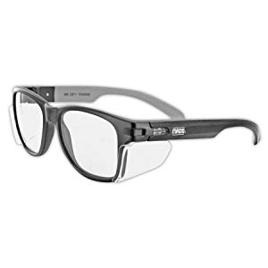
Black Framed Safety Glasses
https://amzn.to/2NhDin1
$7.36
These are the safety glasses I wear most often. They’re modern, subtle, safe, and fashionable while not breaking the bank. Safety glasses are the most important tool in the shop, make sure you’ve got some that you like to wear!

Gold Framed Safety Glasses
https://amzn.to/2POM1yr
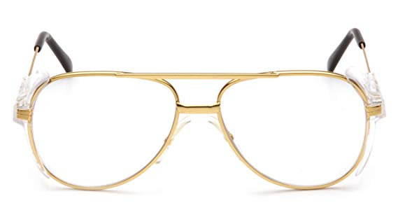
$7.84
Safety glasses are important, and these are fashionable! Get a few sets, you’re definitely going to lose them.

Caramel Framed Safety Glasses
https://amzn.to/2pxrPGW
$6.55
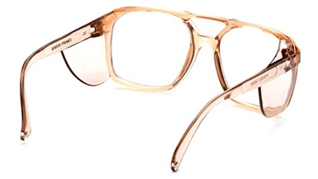
One of my favorite sets of “hipster” safety glasses which we use in classes and youtube videos. These provide the proper eye protection, while looking retro!

Fit Over Style Safety Glasses
https://amzn.to/2LWdAmY
$3.98
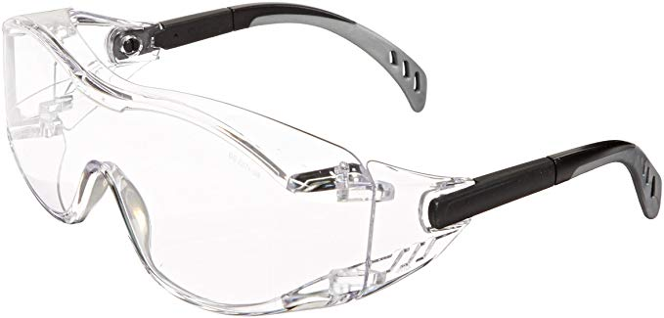
Finally, a set of safety glasses we’ve found that actually fit comfortably over your prescription lenses! They don’t feel like highschool chemistry class goggles, they don’t fog up, and they actually fit!

Kids Sized Safety Glasses
https://amzn.to/2qnlwpE
6 pack $9.99
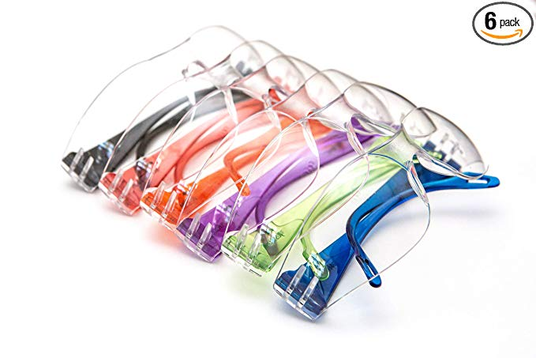
Finding Safety glasses that ACTUALLY fit kids is tricky! If you’ve got kids in the shop, you should have kids sized safety glasses in the shop! This set seems to work pretty well, and by having them in different colors- every kid can have their own set.

ISOtunes PRO Bluetooth Hearing Protection, 27 dB Noise Reduction Rating
Affiliate Link: http://bit.ly/2NUNYXA
$89.99
Use discount code “thebarefootforge” to save an additional $10 at checkout!
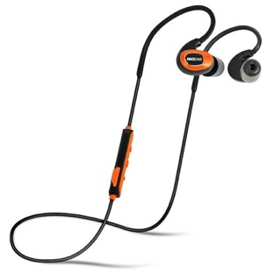
Bluetooth Hearing protection so you can preserve your ears while still listening to podcasts. I wear these all day, every day! Built for a shop environment and built to have real hearing protection, not just “noise cancelation”.

Wall Control-The metal pegboard panels we LOVE for shop and garage organization:
https://www.wallcontrol.com
$80-300
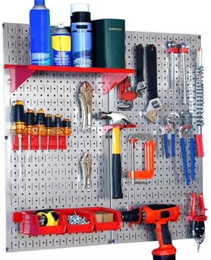
This is truly one of my favorite products to showcase in our shop. This is an incredible improvement on the age old “pegboard”. There’s a variety of hooks, shelves, bins, etc that will keep you organized, are easy to clean, and so much stronger then they need to be! I routinely put a small anvil on one of these shelves!

1.75lb Hammer we used in class
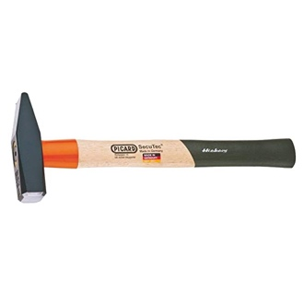
https://amzn.to/2qm4iIS
Most people getting into this trade are swinging way too large of a hammer. This 1.75lb hammer is the best readily available/affordable hammer we’ve found, and it’s great for the budding blacksmith! Just reprofile the face a little with a file or grinder, and this will become your new “GO-TO” hammer!
KSEIBI 1.1lb Cross Pien Hammer
https://amzn.to/2TGC8U9
$16.84
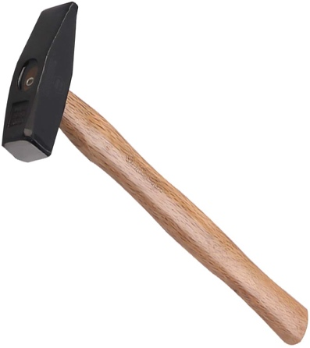
Most people getting into this trade are swinging way too large of a hammer. This 1.1lb hammer is a great “light” hammer for those projects and individuals that benefit from a little lighter hammer! Just reprofile the face a little with a file or grinder, it’s a great addition to any shop.

Wooden Mallet for straightening:
https://amzn.to/39nI1fz
$18.87
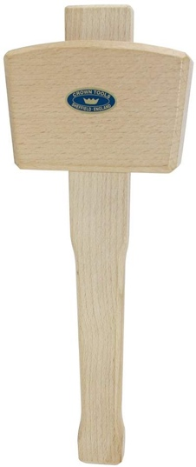
This is the mallet we use for straightening hot steel. If you’ve twisted a handle in a bottle opener or knife and need to straighten it without ruining the twist- this is the way to go!
They wear out, but you’ll get more then a few good WHACKs with it.

5/8’’ V Jaw Tongs we used in class- perfect for railroad spikes
https://amzn.to/2WGGnzS
$57.40
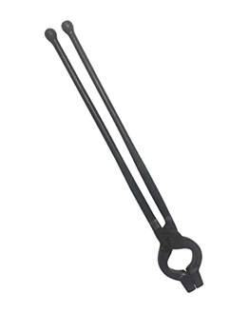
This is a pretty good set of 5/8’’ “V JAW” tongs which work well with railroad spikes. Since lots of beginner smiths love making things with railroad spikes, these are a pretty good set for starting off.
(Sometimes they need to be reforged slightly to better fit the spike head. Just heat the tongs up with the spike in place, and give them a few “adjustments”).

DIY “Quick Tongs” Starter Kit by Ken’s Custom Iron
https://amzn.to/2PMZib6
$74.72
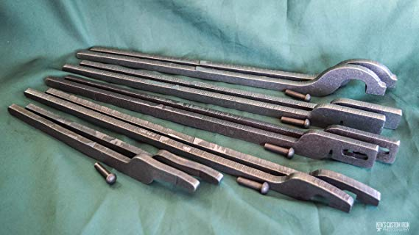
Every aspiring smith needs a variety of tongs, and Ken’s Quick Tongs are a great and affordable way to build a few sets of our own, specific to what you need. They come with detailed instructions and this starter kit is perfect for anyone starting out and in need of tongs. We still use these, constantly, it’s great to have some half made tongs ready to go when you need to make something specialty in a pinch!

Lincoln Power MIG 140MP MIG Welder
https://amzn.to/2C3fdcV
$849

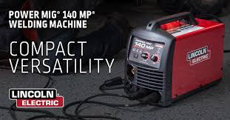
This is the welder we use in class that’s capable of both MIG, TIG, and running a spool gun for aluminum. This is a very versatile and high quality 110v MIG setup- I’m a big fan. This is a great first welder, because this is a welder that you can grow with! Seriously- this welder is AWESOME.
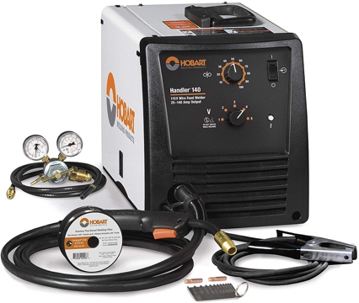
Hobart 500559 Handler 140 MIG Welder 115V
https://amzn.to/2owkuGW
$499
This is the dedicated MIG welder I recommend the most. It’s the best bang for the buck, built by Miller, and these genuinely last 20 years. I’ve owned 5 of them, one of which was over 25 years old and truly fantastic. This is the best dedicated 110v welder for the money that exists.

Lincoln Electric 3350 Welding Helmet, Black
https://amzn.to/2BVaxWv
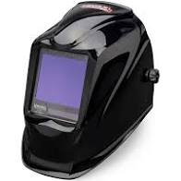
$266
This is the best welding helmet I’ve ever used. It’s exponentially nicer then the $50 one we use in class, and it makes it A LOT easier to become a better welder, as you’ll see EVERYTHING. If you currently suck at welding and want to get better- this tool will make that journey ALOT shorter!

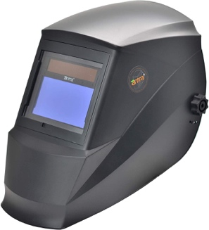
Antra Auto Darkening Welding Helmet
https://amzn.to/2oyDnZZ
$49.99
This is the cheap welding helmet we used. It works great for the $50 price.

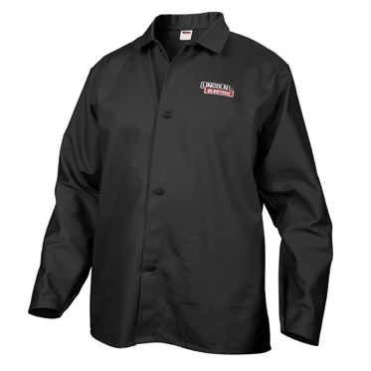
Lincoln Electric Black Large Flame-Resistant Cloth Welding Jacket
https://amzn.to/2q6jnhB
$30
This is the basic Lincoln welding jacket we wore, it’s good- you need one. Make sure you get the right size.

Lincoln Electric Leather TIG Welding Gloves
https://amzn.to/2x8DY8t
$17.89
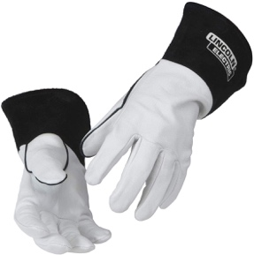
These are great, comfortable, durable gloves that work great in our welding classes. They’re thin enough to have lots of dexterity, but sufficient to protect from UV and short term heat exposure. They’re really comfortable.

Ameribrade Grinder
https://www.ameribrade.com/shop
Our model is the variable speed 2hp with 110v input, 7’’ drive wheel, and we have several other attachments including the work rest, small wheels, and large wheel.
$1529 priced as we have it.
Grizzly G1015 2x72’’ Belt Sander/Buffer
https://amzn.to/2P6Xqrr
$612.95
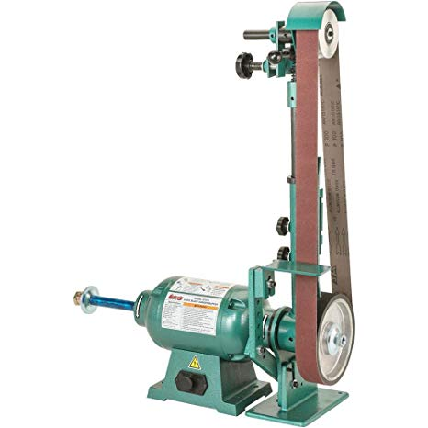
This grinder has proven to be the best entry level grinder you can buy. I’ve owned several of these and they’ll last you years of great service. Plenty of power and a very versatile machine for a lot less than other dedicated 2x72 knife grinders!

Grizzly 1x30’’ Belt Grinder
https://amzn.to/2Tofj8P
$143.95
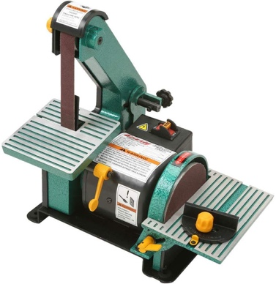
This is the 1x30 grinder we use for small work and jewelry processes in the shop. It has a disk sander on the side which has proven useful before, and it’s powerful enough, when paired with the correct (Aggressive, Ceramic) belts to do some pretty good grinding on steel. It’s a great addition to any shop or garage, and a fine entry level tool.
Combat Abrasives
https://www.combatabrasives.com/?rfsn=3727871.14dd5c&utm_source=refersion&utm_medium=affiliate&utm_campaign=3727871.14dd5c
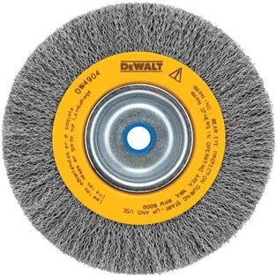
Specifically for our tribe- Save 15% off all orders automatically by following that affiliate link! Discount will be applied at checkout.
We use mainly 36 gritt Ceramic belts, 120gritt aluminum oxide or ceramic, 400 gritt aluminum oxide, and 600gritt aluminum oxide
Wire Wheel For Bench Grinder (we use it on the grizzly 2x72)
https://amzn.to/38rQHQt
$12.75
This particular wire wheel has proven to outlast the ones from the local hardware store. It’s affordable, durable, and gets the job done.

Additional Safety switch we wire into all our machines/benches
https://amzn.to/3apMD4P
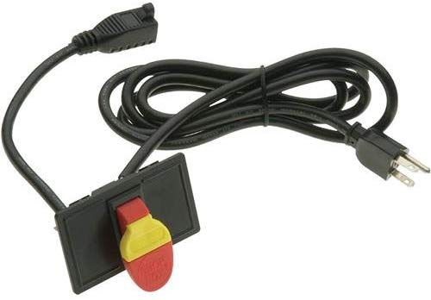
$21.44
We use this simple, pre wired switch to add an additional level of safety to our shopt tools. Removing the yellow “key” makes it so the tool is effectively “Locked out” and your kids can’t accidently turn on your grinder. By mounting it a few feet away from the machine but within arms reach, it also adds a certain level of redundancy as an additional emergency stop switch. We also like to mount it along side this “emergency shut off” sticker to make it nice and clear, $5 well spent. https://amzn.to/32OanNo

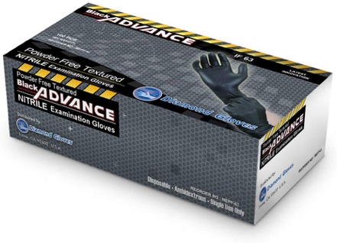
Nitrile Gloves we use in the shop
https://amzn.to/3cwJ52A
$14.55
These are the gloves we’ve been using in the shop for acid etching, polishing, and a variety of mechanical and cleaning operations. These are durable and work great in the garage for working on cars. I’ve tried a lot of gloves, and I’m thrilled to keep reordering these!

Ferric Chloride we use for Etching Damascus
https://amzn.to/3cyBeRW
$22.06
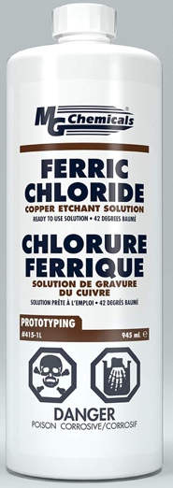
This is the etchant we use for etching Damascus and stainless Damascus steel. We mix one part FeCl with 2 parts DISTILLED water (always, only Distilled), shake it well right before using it- you want lots of oxygen in there, then insert your piece for etching. Usually 10-20 minutes of etching total, with stops every 2-5 minutes to rub off the carbon layer with a tissue. Once the etchant gets saturated, it will start etching more slowly or begin leaving pits in the metal- use freshly mixed etchant for piece you care about. Always dispose of it properly by paying your local disposal company- as this stuff is VERY bad for the environment (particularly creeks and bodies of water).
Total Boat High Performance Epoxy
https://amzn.to/2x8sstL
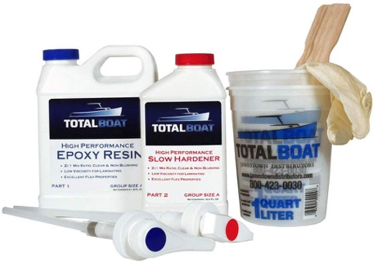
$59.99 for a 1quart kit
This is the epoxy we used for the bulk of the build up of our coffee table build, but we also use small quantities of this all throughout the shop all the time. This stuff works great for sticking things together, dries clear, and is easy to dispense and mix in various quantities.
Total Boat Table Top Epoxy
https://amzn.to/2wvlej4
$64.99 for a 1 Gallon kit
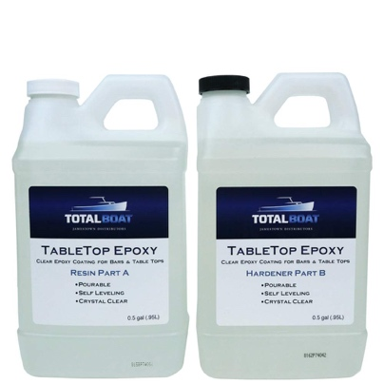
We use this epoxy for coating knife handles, pouring over objects we wish to encase in resin, and the river/top portion of our coffee table build. This dries crystal clear and is easy to work with.

Beeswax for Darkening Metal
https://amzn.to/38l23FV
$43.95 for 5lbs

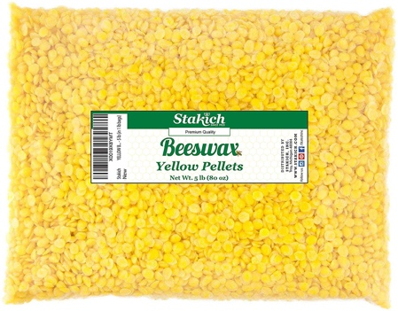
This is one of the sources of bees wax we use when our bees aren’t producing much. Melt this, and mix it with boiled linseed oil and turpentine in a ratio of 1 part liquid beeswax, to one part boiled linseed Oil, to ½ part turpentine in a paint can (available new at Home Depot for about $5) and put WARM metal in here to allow the pores of the metal to accept a bit of this mix. If it’s glowing- it’s too hot to put in the mix.

